Overview of using search to solve a Sudoku puzzle.

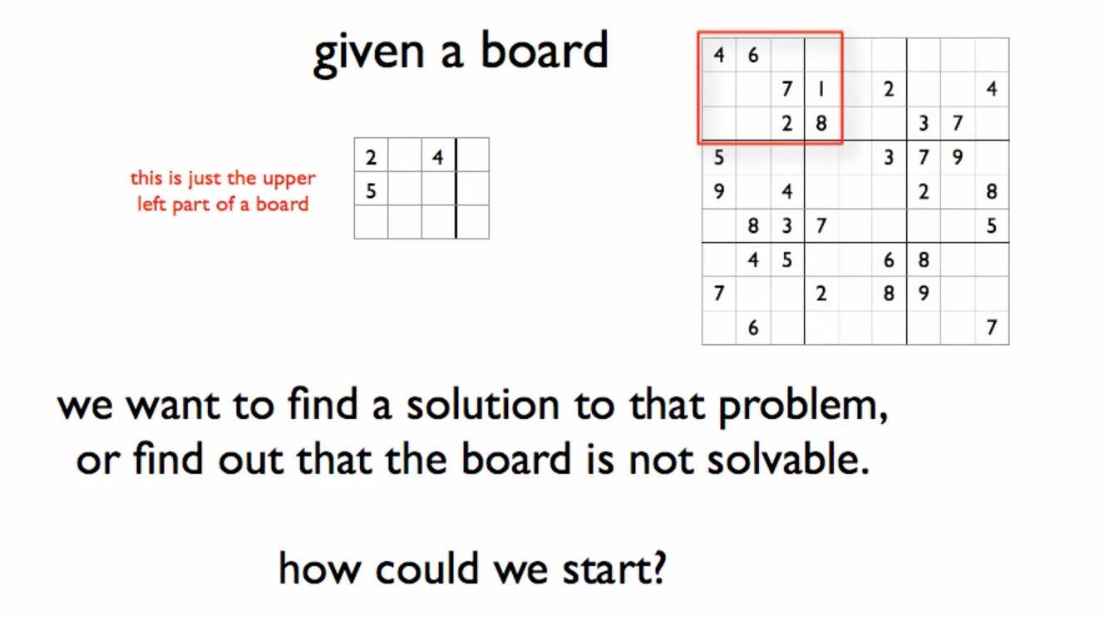

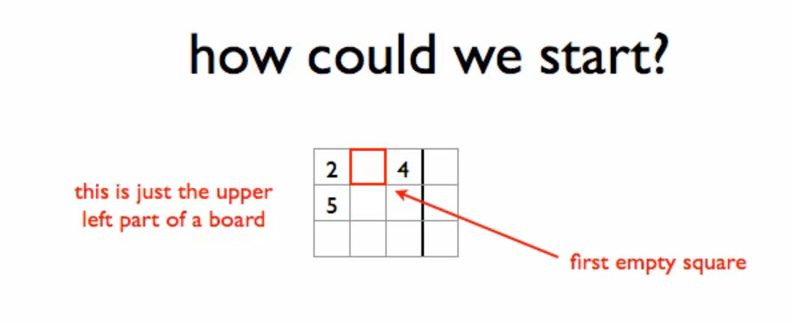

Fill the empty square

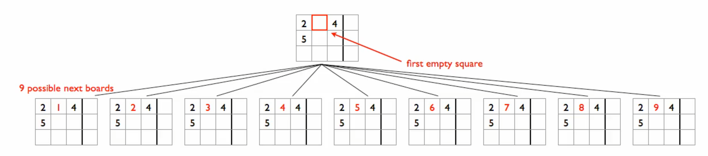

Cross out all invalid boards

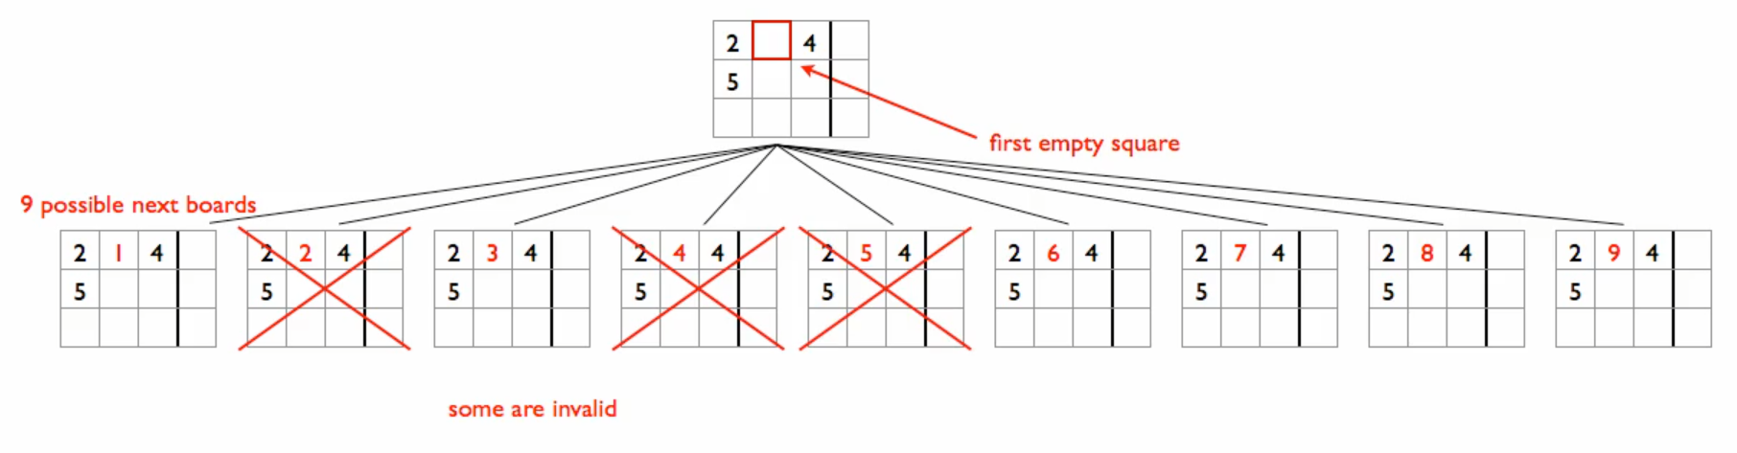

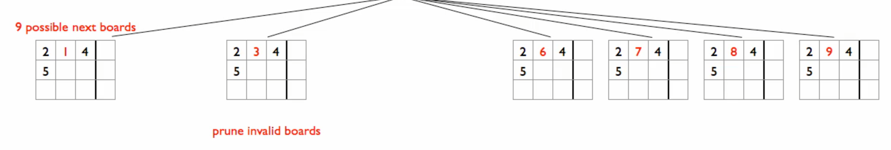

Then we do the same thing again, fill in the next empty square

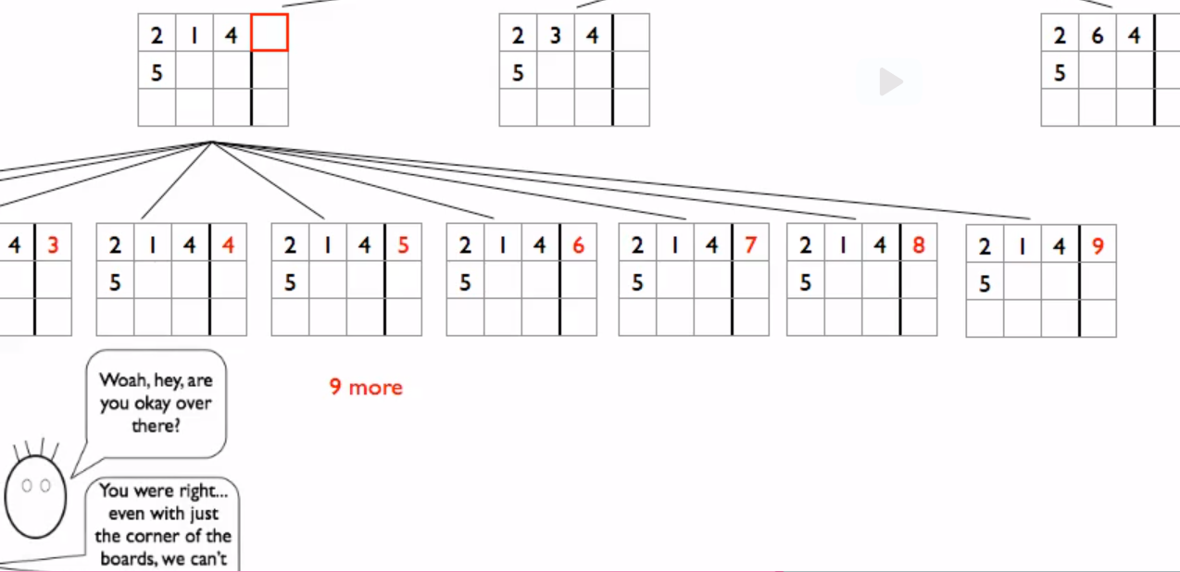

Then cross out

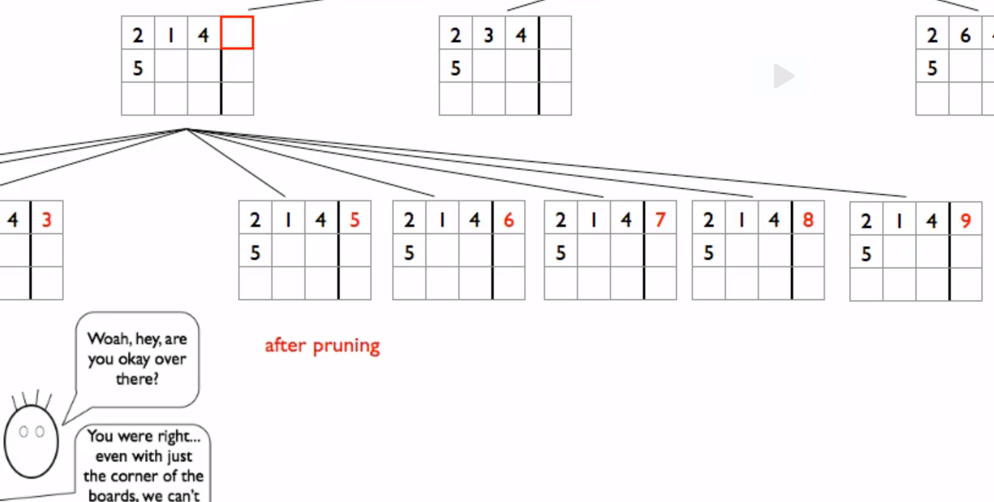

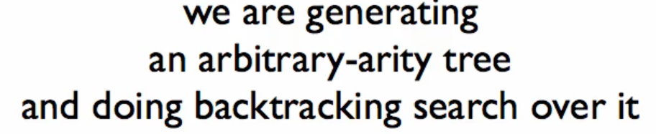

3 aspects to the core structure of our function

**We are generating (Generation)**

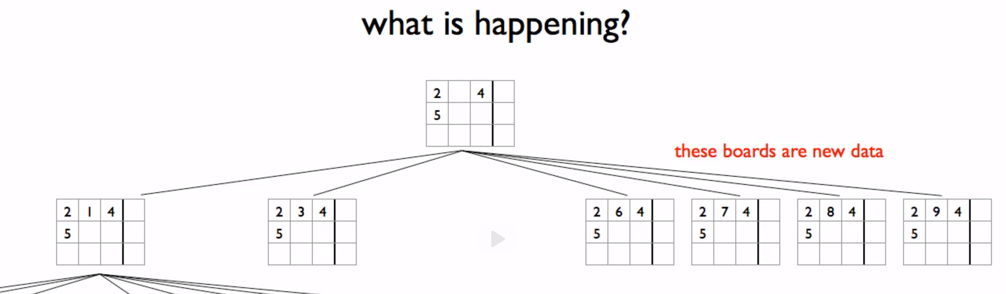

* Generative recursion

**Arbitrary-arity tree**

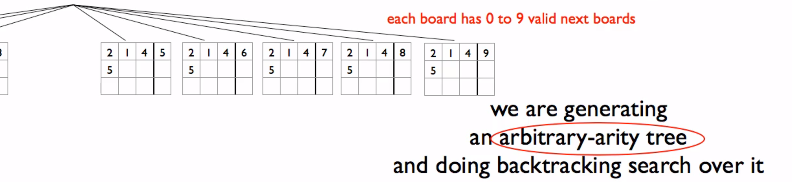

* We are not sure of the limit of the next board (up to 9)

**Backtracking search over it**

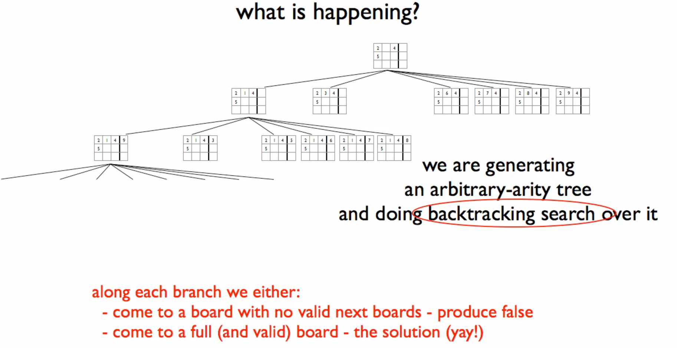

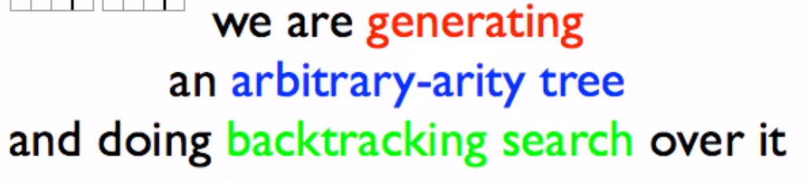

* It’s a generative recursion
* It’s a recursion over arbitrary-arity tree
* And we’re doing backtracking search over it